Copyright Information
Permission is granted to copy, distribute, and/or modify this document under the terms of the GNU Free Documentation License, Version 1.2 or any later version published by the Free Software Foundation; with no Invariant Sections, no Front-Cover Texts, and no Back-Cover.
This is a project of Wikijunior, a collection of free books written especially for kids to learn about science and nature. Many people have been involved with writing this book. This project is hosted on Wikibooks, and you are encouraged to help participate with writing and editing these books.
This document is reproduced under the conditions of the GNU Free License.

Table of Contents
Solar System 1
What is the Solar System? 1
Who Discovered It? 2
How Was It Formed? 3
What Will Happen To It? 4
The Sun 5
What Happens Inside The Sun? 5
What are Sunspots? 7
What Is the Solar Atmosphere Like? 8
Prominences and Solar Flares 8
Chromosphere 8
Corona 9
Solar Wind 9
Zodiacal Light 10
Heliopause 10
What is Solar Weather? 11
How the Solar System Was Born 12
Big Bang Theory 12
Solar System Formation 12
Glossary 13

Solar System
People have been watching the sky for thousands of years and wondering exactly what is out there. With advances in telescopes as well as spaceships, which have physically traveled to various planets, a considerable amount of knowledge has been obtained to better understand the universe near to us.
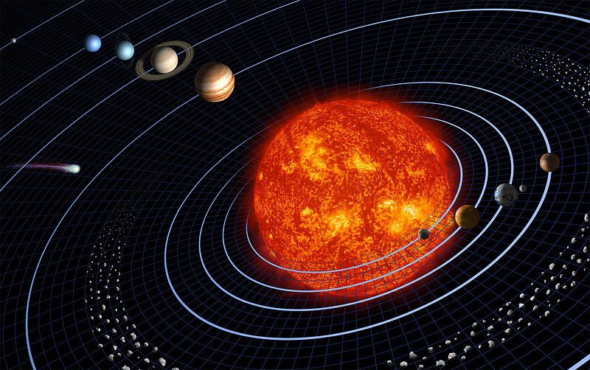

What is the Solar System?
At the center of the Solar System is the Sun. This is but one of billions of stars in the sky, but it is important to us because it gives us warmth and energy to use. There are many worlds that are near the Sun, and each of them are as different as you can possibly imagine. All of these worlds that either orbit the Sun or orbit a planet going around the Sun make up what we call the Solar System. As you read each of the sections about these different planets, we will explore the differences between all of these planets, and hopefully you will understand how unique and special the Earth is as well.
There are a total of eight planets in our system. The inner-most planet is called Mercury. This is followed by Venus and then our Earth. Beyond Earth is an orange-hued planet called Mars. In the outer part of the system are four giant planets called Jupiter, Saturn, Uranus, and Neptune.
Our system also includes many other bodies. The moons are smaller celestial bodies that orbit the planets, in much the same way as the planets orbit the Sun. There are also a lot of much smaller objects called asteroids. These are big chunks of rock or metal that are mostly found orbiting the Sun between Mars and Jupiter. We also get visitors from the cold outer edge of our system that are called comets. These are big lumps of ice and dust. Comets can form immense tails when they come close to the Sun and start to melt.
The solar wind is a hot gas that erupts from the sun and flies away into space. This gas travels past the planets into outer space. This gas reaches the very thin gas between the stars at the edge of the solar system. This bubble of gas is about 100 times as far from us as the Earth is from the Sun. Beyond that is a lot of empty space. The nearest star to the Sun is thousands of times further away than the size of the entire Solar System. It's a very, very big universe out there.

Who Discovered It?
Prior to 1781, there were only seven known bodies in our solar system, besides the Earth. These seven were the Sun, our Moon, Mercury, Venus, Mars, Jupiter, and Saturn. These had been known since humans first began to observe the sky at night. Comets would also appear in the sky for a time, then fade away.
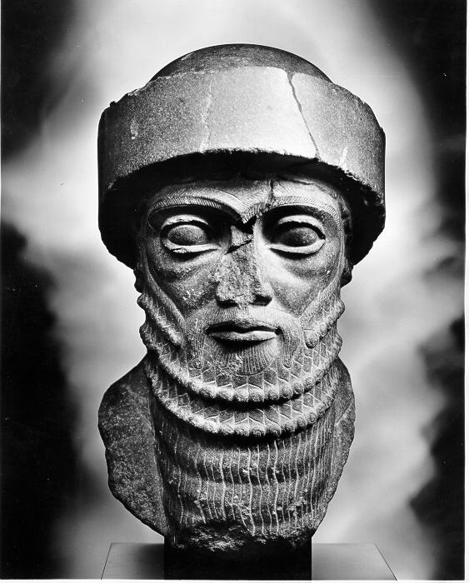
The Babylonians believed that each of these objects was related to a different deity, and their calendar used a seven-day week. The practice of naming the seven visible objects of the solar system still continues to this day. Each of the English words for the day of the week comes from an old name for a god or goddess. In English this is a mixture of both Norse and Roman gods, but in other languages the connection to the Roman names of the planets is more apparent.
Figure 1: Babylonians
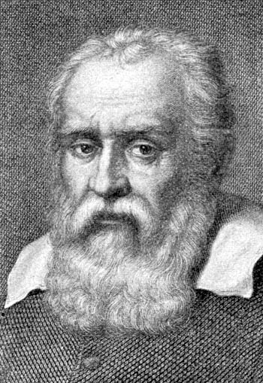
Galileo Galilei first turned a telescope on the sky and began to write down what he saw. Among the things he saw were four moons orbiting Jupiter. As time passed and the telescope was improved, more objects were found. In 1655, Christiaan Huygens discovered the moon Titan orbiting Saturn. In 1781 Sir William Herschel discovered the planet Uranus. In 1801, Giuseppe Piazzi discovered the first asteroid. Many more asteroids were later discovered by astronomers.
Figure 2: Galileo Galilei
The discovery of the planet Neptune did not come by chance, but was found using math. Astronomers had made tables of where each body should appear in the future. But Uranus did not match the predictions. So a model was made to account for the difference. This model predicted that the gravity from an unknown planet was pulling on Uranus. The model also predicted about where the mystery planet would be found. This planet was then found in 1846. For a time, a ninth planet, Pluto, was also recognized. It was found using this same method. Discovered in 1930, in 2006 scientists classified it as a dwarf planet instead.

How Was It Formed?
Our Solar System is part of a much larger system called the Milky Way galaxy. This is a vast mix of dust, gas, stars, and other objects. Our galaxy rotates about the center, and if you could see it from a long, long way off it would look like a wispy pin-wheel.

3: Formation process

What Will Happen To It?
About four thousand million years from now, the Sun will have used up most of fuel. It will begin to enter the final stages of its life. It will expand into a huge star called a Supergiant. The size of this star will be so big that several of its planets will be inside, including the Earth. These planets will be burnt to a crisp inside the very hot atmosphere.
Eventually the sun will begin to throw off its outer atmosphere, forming an immense sphere of faintly glowing gas that astronomers call a planetary nebula. The sun will then shrink down into a small star called a white dwarf. This will be about one hundredth the size of our current sun. It will then slowly begin to cool and grow ever fainter over time.

The Sun
The Sun is a large ball of very hot gas, mostly hydrogen and helium. It is the power house of the Solar System. It's our nearest star. Without the sun there would be no life on Earth. We depend on the sun for energy. If the sun blew up, it would take about 8 minutes before anyone noticed.
It produces light and heat energy needed for life. Every second, over 4 million tons of material is converted into energy through nuclear fusion.
The equator of the sun rotates much faster than areas closer to the solar poles.
Never look directly at the sun without filters. A passing glance will cause temporary blindness, and looking at the sun without special filters in a telescope will cause permanent blindness.
The Sun is very big - much, MUCH bigger than the Earth! It is 1,392,000 km, or 109 Earths across, and contains more than 99.9% of the solar system's mass. If you could somehow stand on the surface of the Sun, you would weigh 28 times as much. A grown person would weigh as much as a car.
More than a million Earths could fit into the volume of the sun! It doesn't look that big from where we stand, though. That's because the sun is about 150,000,000 km away. At that distance, it takes light from the sun over eight minutes to reach the Earth. Compared to other stars, the sun is about average-sized.

What Happens Inside The Sun?
The sun is the main source of energy for the earth. This energy is released deep within the sun in a process called atomic fusion. Four hydrogen atoms are fused together to make one helium atom. The helium atom has slightly less mass than the four hydrogen atoms; the extra mass is converted to energy. This is the same way energy is released in a nuclear bomb called a hydrogen bomb.
The Core: The center of the Sun is very dense. It's about 12 times as dense as lead. It's also very hot about 15 million °C. This region is where most of the nuclear reactions are taking place.
The Radiation Zone: In this zone the light, heat, and X-rays produced in the core fight their way out towards the surface. The gases that make up the zone are still very dense and keep absorbing and emitting the rays. Have you ever tried to run through water? That's what it's like for light waves in this region of the sun. It can take a single ray of light a million years to make its way out of this zone.
The Convection Zone: Have you ever seen the air shimmer above a fire? Perhaps you've been told it's because "heat rises"? Heat doesn't rise all by itself. It is the hot air that is rising. Hot gases tend to rise, and cold gases tend to sink. In this outer region of the sun the gases are less dense and so behave more like ordinary gases that we see on Earth. At the bottom of the convection zone the gas gets heated up by the energy that is coming through the radiation zone from the core. This gas rises up to the surface of the sun where it gives up its heat and cools down. The now cold gas then sinks back down. The plumes of rising hot gas and sinking cool gas together form huge ribbons of circulating gas known as convection cells.

What are Sunspots?
Sunspots are slightly cooler areas on the surface of the sun that appear as dark areas. They only appear dark against the brightness of the rest of the surface of the sun. Despite their appearance, they are still extremely bright — brighter than an electric arc. The number of sunspots seen rises and falls over an 11 year cycle.
Sunspots appear when the Sun's magnetic field is concentrated, impeding the flow of energy. A typical sunspot consists of a dark region, called the Umbra, surrounded by a lighter region, called the Penumbra. The Umbra is about 2000 °C (3600 °F) cooler than the photosphere and only looks dark in relation to its surroundings. Spots usually form in groups which are carried across the solar disk by the Sun's rotation.
Over a period of about 11 years, sunspot numbers increase before decreasing slowly. This sunspot cycle happens at about the same time as the increase and decrease in the Sun's overall activity.
The most complex sunspots are hubs of intense magnetic fields. These active regions can suddenly erupt as flares that are short-lived, extremely bright areas that release large amounts of charged particles and radiation. Flares are more prevalent during peaks in solar activity.

What Is the Solar Atmosphere Like?
The part of the sun that you see in the sky is called the photosphere. This is where the pressure from the gases inside the sun is low enough that they no longer glow so bright, and is generally considered the "surface" of the sun. Everything that is below the photosphere gives off light. The photosphere is also the very top of the convective zone of the sun. It is on the photosphere that you see sunspots.
While you can say that the atmosphere of the sun begins at the photosphere, in reality the entire sun is one very large ball of gases, where there is no definite beginning or end to the gases from the Sun. Because the Sun is so hot, gases from the sun are constantly streaming outward and form various parts of the solar atmosphere, which extends beyond even the orbit of Pluto. These gases near the Earth are very thin, with so little in the way of gas pressure that you can basically call it a vacuum, but it still is enough that it pushes away gases from other stars in our galaxy. It is only until you get to the heliopause that you can say that the influence of the Sun's atmosphere ends.
Various parts of the solar atmosphere are as follows.

Prominences and Solar Flares
When you look at the sun through a telescope (with special filters so your eyes don't get damaged!), at the sides of the photosphere there appear to be large eruptions of gases like it was from a volcano. Each of these is called a prominence. There have been several kinds of prominences, but all of them are very large. Ones you can see are hundreds of kilometers long, and the largest was almost 400,000 kilometers. That is almost twice as far as the moon is from the Earth. These prominences are related to sunspots, because they are often seen as coming from a sunspot. The largest of these prominences sometimes become so large that they leave the sun entirely, and that is when they become a solar flare.

Chromosphere
When early astronomers viewed the sun during an eclipse, they noticed that there was a brief flash of light immediately before and after the eclipse. Instead of being a steady white light, it seemed to be a rainbow spectrum of all of the colors you can see, which is what gives the chromosphere its name. It is not as bright as the photosphere, which is why you normally don't see it during the day, but only during an eclipse.

Corona
Even fainter than the photosphere or chromosphere is the corona. This is a region extending from the chromosphere and gradually becoming a part of the solar wind throughout the rest of the solar system. The reason why the corona glows is because the gases in the corona are actually hotter than the surface of the Sun! The reason why this happens is still a mystery to scientists, but there are several theories for what is happening. The corona will shift and change, sometimes very rapidly over minutes or hours, due to changes from the sun itself. Because the photosphere is so bright, it is difficult to observe the corona except during an eclipse even with advanced scientific instruments. Some telescopes in space are making it easier to observe the corona, but it is still something that scientists are trying to understand.

Solar Wind
As the corona gets further from the sun, it is still "blowing" against all of the planets in the solar system. This is called the solar wind. While the gas pressure is very low, it still is enough that some very light objects and other gases are pushed away with the solar wind. For other astronomical object, this is visible with the two comet "tails,” where one "tail" is mainly rocks and dust, with the other "tail" composed of gases. This second tail is being pushed by the solar wind and causes its effect.
In 1960, the Satellite Echo I entered orbit and was one of the largest satellites ever put into space, in terms of volume. Basically it was a large balloon that was inflated by a small amount of gases inside. Because it was so light but also very large, its orbit was substantially affected by the solar wind and other solar pressures. Even more compact satellites still have to take solar wind into account when planning orbits and how long a satellite will stay in orbit.

Zodiacal Light
If you travel to a place very far away from any cities and look up at the night sky, a very faint glow will come from a band across the sky in roughly the same part of the sky that you see the other planets. This is not the Milky Way, which is also visible, but even fainter than that. This is actually sunlight which is reflected off of dust and meteoroids that are found throughout the ecliptic plane. This dust is the remains of comets and asteroids colliding with each other and eventually falls into the sun over millions of years.

Heliopause
The Heliopause is what can largely be considered the edge of the solar system. This is where the solar wind slows down and stops (or "pauses") due to the "solar wind" coming from other stars in the galaxy. There is a region just inside the heliopause where the solar wind slows down from supersonic speeds (literally, faster than sound) to subsonic speeds.

What is Solar Weather?
Solar weather is a new science, but something that has a huge impact on a number of things here on the Earth. When a solar flare is produced on the sun, it includes a large amount of plasma, or very hot gases. If this flare then heads toward the Earth, it will cause a number of problems, including blackouts on electrical power systems in large cities, communications disruptions with radio transmitters and satellites, and potentially even death if an astronaut is caught unprotected when a large solar storm comes from that flare. Normally the Earth's atmosphere protects us from direct effects of these flares.
These solar flares also cause something called an aurora. This is also known as the "Northern Lights" or "Southern Lights" (depending if you are closer to the north or the south pole), where the plasma interacts with the atmosphere of the Earth and the Earth's magnetic field. You can normally only see this event when you are close to one of the poles, but sometimes a very powerful solar flare will produce an aurora that can be seen as far south as Mexico, or as far north as Southern Brazil, or South Africa.
The aurora is not unique to the Earth either. Auroras have been seen on all of the planets except for Mercury and Pluto by telescopes and space probes. The aurora on Pluto has not been seen because it is so far away and no space probes have ever been there, and Mercury doesn't have a substantial atmosphere.
Just like there are weather forecasts for weather on the Earth, there are weather forecasters that study solar weather and try to predict when solar storms will come. Not only do they study just what will happen near the Earth, but they also try to predict what is going to happen in other parts of the solar system. As more space missions go into other parts of the solar system, this will become even more important. To help make the predictions, they also study the sun itself, and try to determine in advance when a solar flare will occur.

How the Solar System Was Born
Our solar system is a part of an entity called our universe. There were many attempts made in the past to explain how our solar system and universe came into existence as we observe it today. The currently accepted theory of the universe's formation is called the Big Bang Theory.

Big Bang Theory
This theory is based around the idea that an enormous explosion occurred about
13.7 billion years ago. That is about 13,700,000,000 years ago. This is three times the age of Earth! The Big Bang was not a usual explosion in space because space and time themselves were made in the explosion. This explosion caused the formation of the matter and energy in the universe. At first, the universe was very hot. The planets, stars and all other heavenly bodies formed starting some time after the Big Bang after the universe had cooled down.
The universe has been expanding and cooling since the Big Bang. Most galaxies are moving further away from our Milky Way galaxy. The exceptions are the few galaxies that are close enough to the Milky Way for gravity to overcome the universe's expansion.
Scientists can still see the faint light from when the universe was hot. Over time, the universe's expansion stretched out the light, turning it into weak microwave light. Scientists can detect this microwave light.

Solar System Formation
The solar system formed out of a big cloud of gas and dust about 4.6 billion years ago.
Stars and solar systems that are very similar to the Sun are now forming in the Eagle Nebula (also known as M16).

Glossary

The name of our system comes from the old Latin word for the Sun: Sol. Because the Sun is the largest object in the system and all the other bodies orbit around it, it became known as the solar system.

